REPUBLIC OF TURKEY SCIENCES COURSE PLAN

CHAPTER I Date: SEPTEMBER 2021
Name of the course |  |  |  | Science
Class |  |  |  | 6
Unit Name |  |  |  | World and Universe
Topic |  |  |  | F.6.1.1. solar system
Recommended Duration |  |  |  | 4 Lesson Hours
CHAPTER II
Student Achievements / Goals and Behaviors |  |  |  | 1. UNIT :F.6.1.1.1. Compares the planets in the solar system with each other.
Unit Concepts and Symbols/Pattern of Behavior |  |  |  | Structure and rotation of the Sun.
Safety Precautions (If Any):
Teaching-Learning-Methods and Techniques |  |  |  | Question-Answer, Invention, Research, Demonstration, Analysis, Experiment
Educational Technologies Used-Tools Materials and Bibliography |  |  |  | Textbook, Smart board, Textbook, Science Flashcards, , Photos,  Web 2.0 tool :  1- https://learningapps.org/10883924  2- https://www.eba.gov.tr/
Explanations |  |  |  | a Basic properties of planets (terrestrial, gaseous, inner planet, outer planet) are mentioned.  b. It is said that planets have moons.
Activities |  |  |  | Groups are formed and planets are modeled with daily materials. Care is taken to ensure that the properties of the planets such as color and size are close to reality.
Topic Summary :

Solar system; It consists of the Sun and its orbiting planets, satellites, asteroids, and comets.

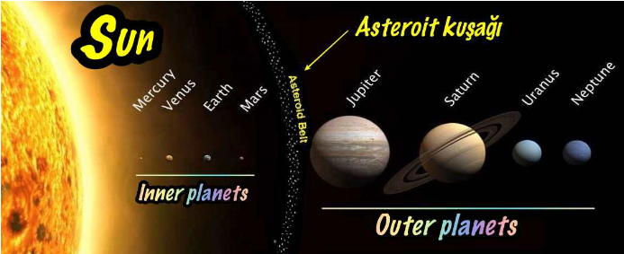

The order of the planets according to their distance from the Sun is as follows: Mercury - Venus - Earth - Mars - Jupiter - Saturn - Uranus - Neptune

Inner Planets Outer Planets They are called gaseous planets because they have structures made up of gases.
It is the closest planet to the Sun and the smallest planet. It is the hottest planet after Venus.
It is the 2nd closest planet to the Sun and the 3rd minor planet. From its atmosphere containing carbon dioxide gas
due to the greenhouse effect. Hence, it is the hottest planet. As Earth's twin
is named. It is popularly known as the "Shepherd's Star". opposite to other planets
rotary. A day lasts longer than a year.
It is the 3rd closest planet to the Sun and the 5th largest planet. Its only natural satellite is the Moon. Over
It is the only planet inhabited by living things.
It is the 4th planet closest to the Sun and the 2nd minor planet. It is known as the Red Planet.
It is the 5th closest planet to the Sun and the largest planet. It can be observed with the naked eye. Most
The name of its big moon is Booty.
It is the 6th planet closest to the Sun and the 2nd largest planet. It can be observed with the naked eye.
Its largest moon is named Titan.
It is the 7th planet in terms of distance from the Sun and the 3rd largest planet. Rolling around the sun
It is the only planet that orbits on its side like a barrel.
It is the farthest planet from the Sun and is the 4th largest planet. It is like the twin of Uranus. It is the coldest planet.

 | CHAPTER III
Assesment and evaluation:

Below are the planets with the Sun. The names of the planets in the image are dotted
Write and answer questions.
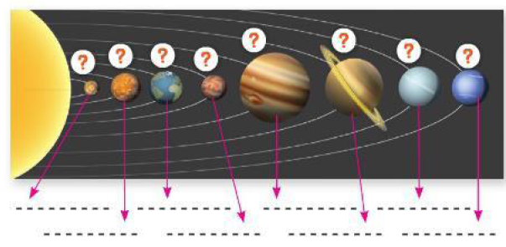 Rank the planets by size?
………………………………………………………………………………………..
Distances of planets from the Sun (from far to near)Sort by?
…………………………………………………………………………………………..

The Relationship of the Course with |  |  |  | Other Courses Since it is a subject related to the geography course, the teacher can exchange ideas with a geography teacher when deemed necessary.
CHAPTER IV
Explanations Regarding the Implementation of the Plan | Precautions should be taken in order to eliminate the problems that may occur during the implementation of the plan, and the plan should be stretched according to regional differences.

Ahmet EKENEL

SCIENCE TEACHER SCHOOL DIRECTOR

Etkinlik Fotoğrafları: Öğrenciler Model ve
Web 2.0 tool : https://learningapps.org/10883924 ile Gezegenleri sıralar.

